Hexaware-GenAI
Unlocking Innovation-
Your Path to AI-Driven Excellence

Scope Of the project
Project Title LangGraph ChatBot Project Objectives: Customer Support Chat Bot Pipeline
Deliverables: User

Design
Design Diagram

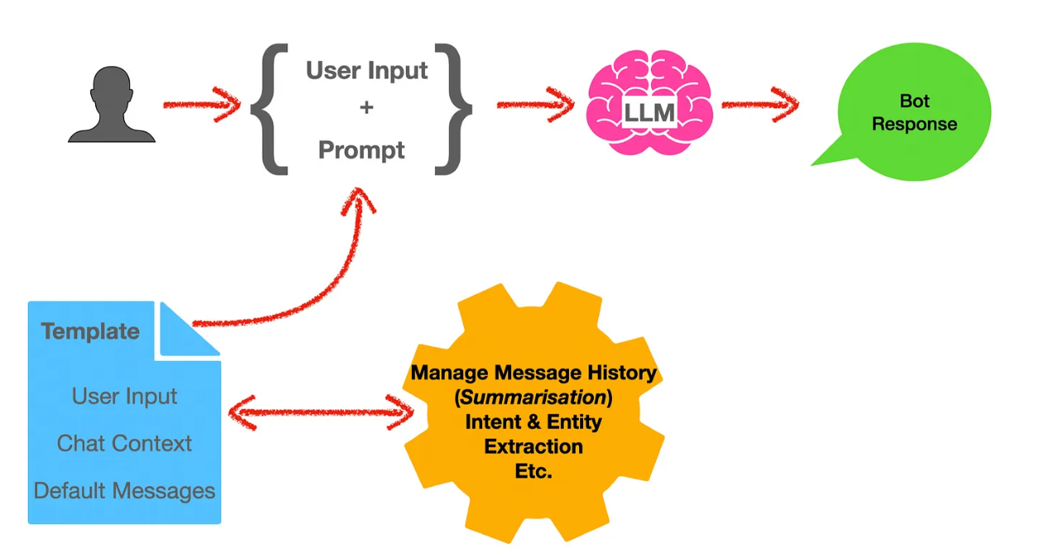

Design
Design Description: Chat Interface:

QA Chatbot Module:

RAG Technique: YES

Azure OpenAI Integration: NA

Design
Workflow

Test Cases
Positive Test Cases
TC 1: Document Upload Success
TC 2: Question Submission and Answer Retrieval TC 3: Embedding Creation and Storage
TC 4: RAG Technique Functionality

Test Cases
Negative Test Cases
TC 6: Document Upload Failure Handling
TC 7: Question Submission with No Document TC 8: Incomplete Embedding Data
TC 9: RAG Technique with Irrelevant Data

Tools and Code details
Third party tools Details:

Tools name | Open source/Licensed | URL | Purpose
Google colab | Open Source | https://colab.research.google.com/drive/1gB9JLwgs-cF91sioPP37f-SoQtWuuKri#scrollTo=sUZXwF1gmnhT | Agent can interact with human
Google colab | Open source | https://colab.research.google.com/drive/1X6uSDJwYkwXa3XzQqpj58uYMxGPKS1mT#scrollTo=cN1ZvcSCPdcZ | m model interact with chat bot application.

Technologies used to develop in this project

Technology name | Version | Purpose
Python | 3.11 | Backend development
LLL Model | 0.3.25 | LLM model(Lang chain& Lang graph)


Thank you

